Exp:1
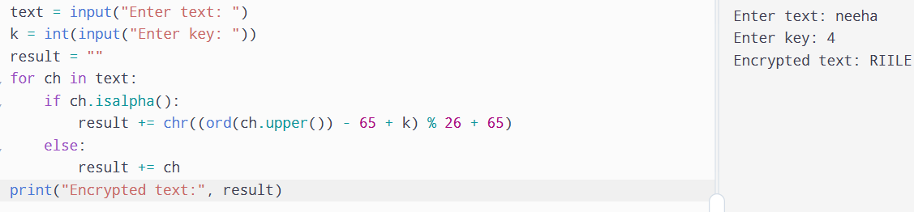
Exp:2
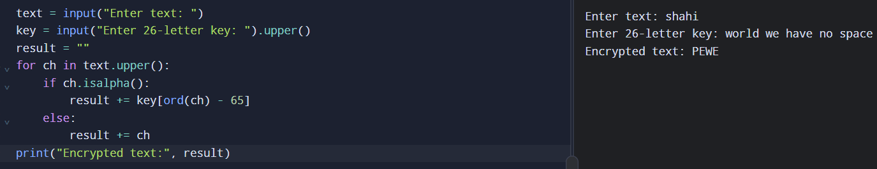
Exp:3
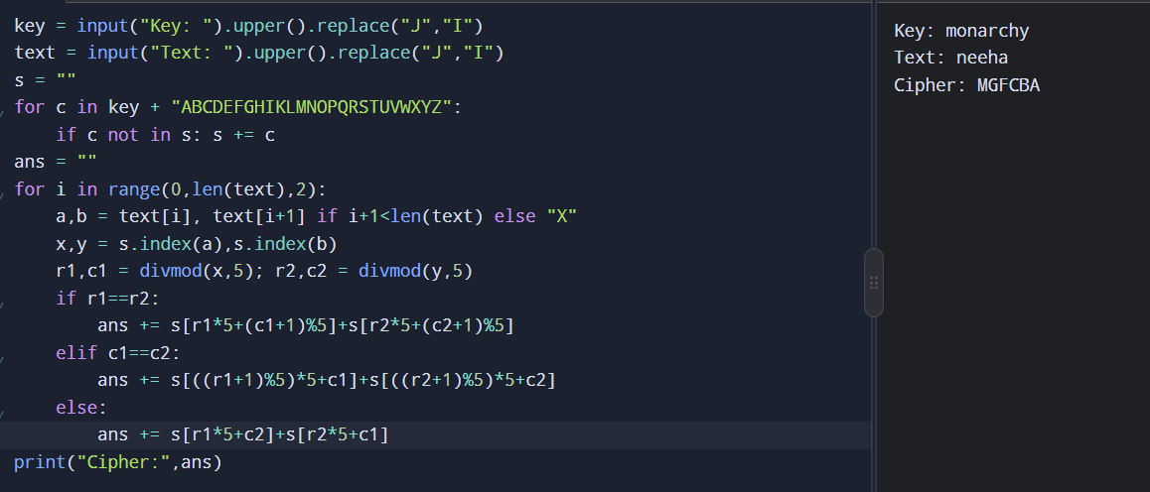
Exp:4
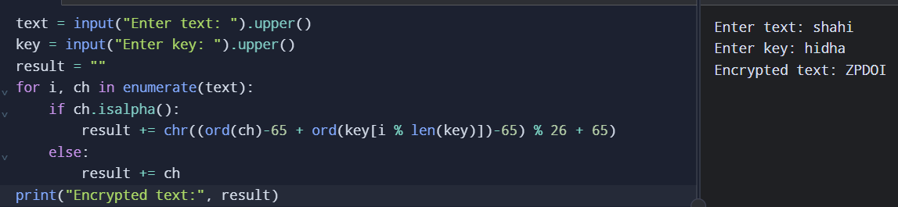
Exp:5
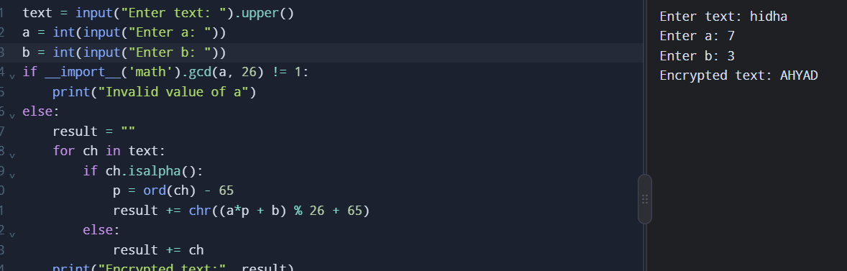
Exp:6
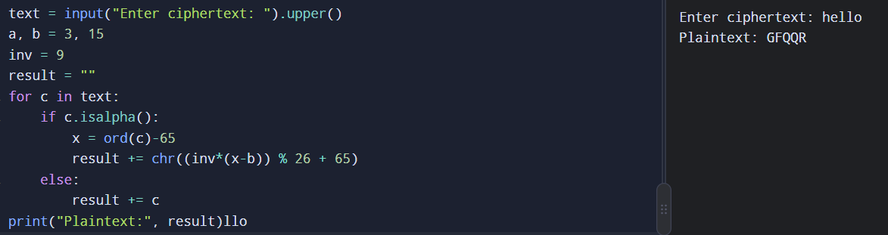
Exp:7
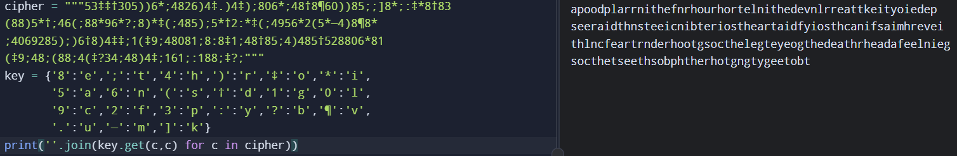
Exp:8
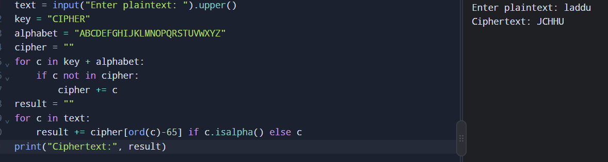
Exp:9
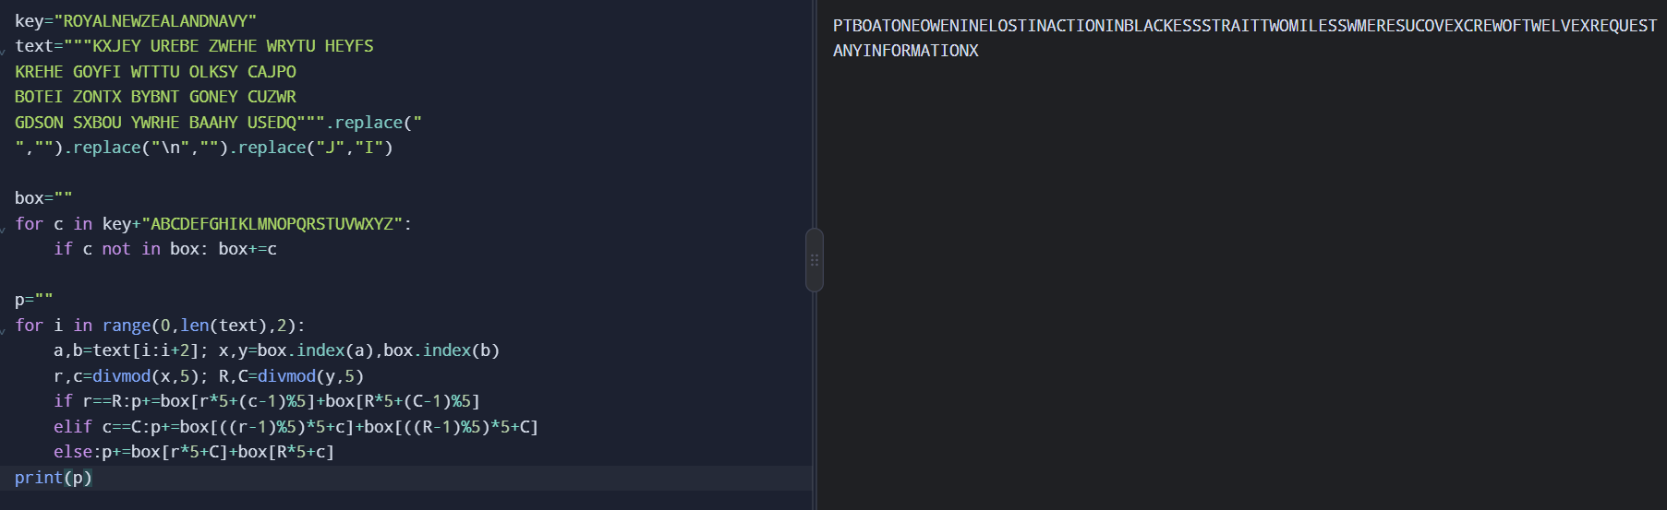
Exp:10
